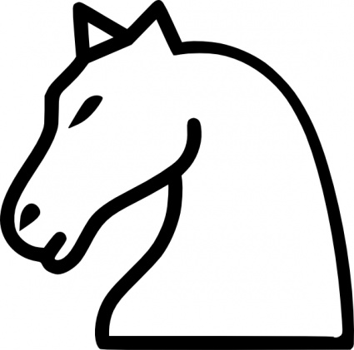

ESCRIBO LA POESIA DEL CABALLO

EL CABALLO

…………………………………………………………………………..….….......…

……………………………………………………….................................…………

……………………………….……………………………………………………….

………………………………………………………….…………….……………..….



                                                                                                    
                                                                                                    
                                                                                                    

                                                                                                    
                                                                                                    
                                                                                                    

